Scholarship Programme SFR 2024

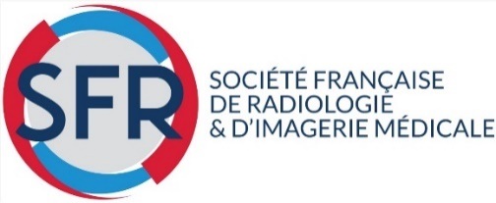

Objective of the Scholarship Programme: To grant a complementary professional internship of up to 3 months with a radiology team in France.

The amount of each scholarship is €5,000.

Requirements:

Radiologist with diploma.

Age limit 35 years.

Member of the SFR.

Candidates should send their applications only by email to claudia.ramos@sfradiologie.org

All information on the SFR website: www.radiologie.fr "Bourses et prix".

SCHOLARSHIP APPLICATION FORM

To be submit before:

May 31, 2024

For an internship period from

September 1st, 2024 to May 31st, 2025

* NOTE: Candidates from Algeria, China, Mauritania, Morocco, Spain, Mauritania and Tunisia, applications must be sent directly to the respective National Society by April 15, 2024. Each National Society will select one or two candidates, whose candidatures will be sent directly to the SFR for selection by the jury of the International Committee.

For these countries, no candidature received directly to the SFR will be considered.

Société Française de Radiologie
47, rue de la Colonie - 75013 Paris – France
claudia.ramos@sfradiologie.org

Personal information

Full Name
(first and last name)

Date of birth

Personal address

Phone: Fax :
E-mail:

Business Address

Phone: Fax :
E-mail:

2. Internship project (30 lines maximum)

3. Documentation to be attached (in PDF)

□ Acceptance letter from the person in charge of the internship period.

□ Letters of recommendation from 2 heads of department in which the candidate has served

□ Letter of recommendation from the National Society of which the candidate is a member

□ Curriculum vitae / Resume

